Bio 100-300

Tanzie Mancini is a Creative advertising student, at the University of San Francisco. She hopes to find a place in the sustainable fashion industry, in creative direction.

Her skills include 6 years of experience in styling, buying, reworking, and reselling clothing. She is also well versed in Adobe Photoshop, Illustrator, and InDesign, as well as HTML & CSS programming, sewing, film photography, and knitting.

Her greatest passion is clothing and their function as a vessel for one’s emotions, creativity, and overall self expression. She also deeply values the creative community that surrounds the clothing industry. She prides herself in having a keen creative eye, especially when it comes to understanding the personal style of others and how to elevate it. She also prides herself in keeping up with current and budding brands and becoming well versed and intuitive when it comes to fashion forecasting.

Byline 1 sentence

* Tanzie is passionate about cultivating and elevating creativity in fashion based environments.

Project Description

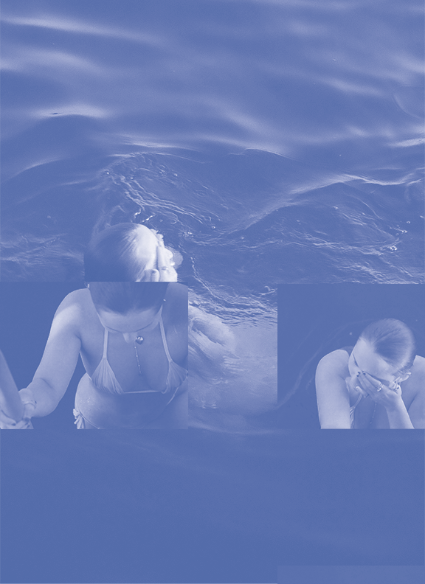

* + Description:
    - This project was shot on 35mm film. I rearranged an overlay of images and manipulated the colors to show a cornflower blue overlay

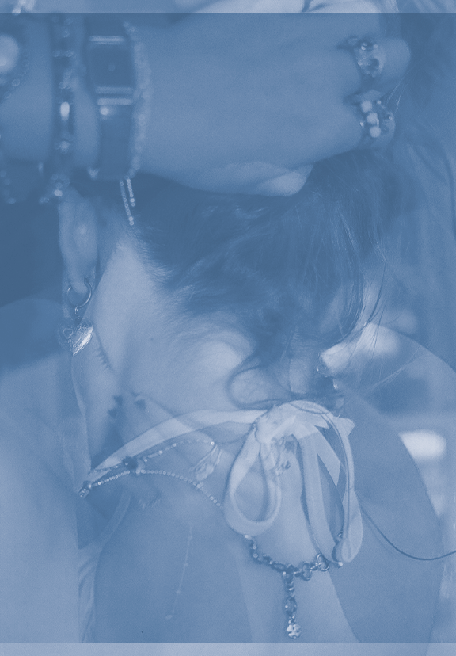

* + Description:
    - This project was shot on 35mm film. I rearranged an overlay of images that I had taken on that same role, then tweaked the colors for a blue overlay. This piece is intended to capture the occasional loneliness of a perfect summer day.

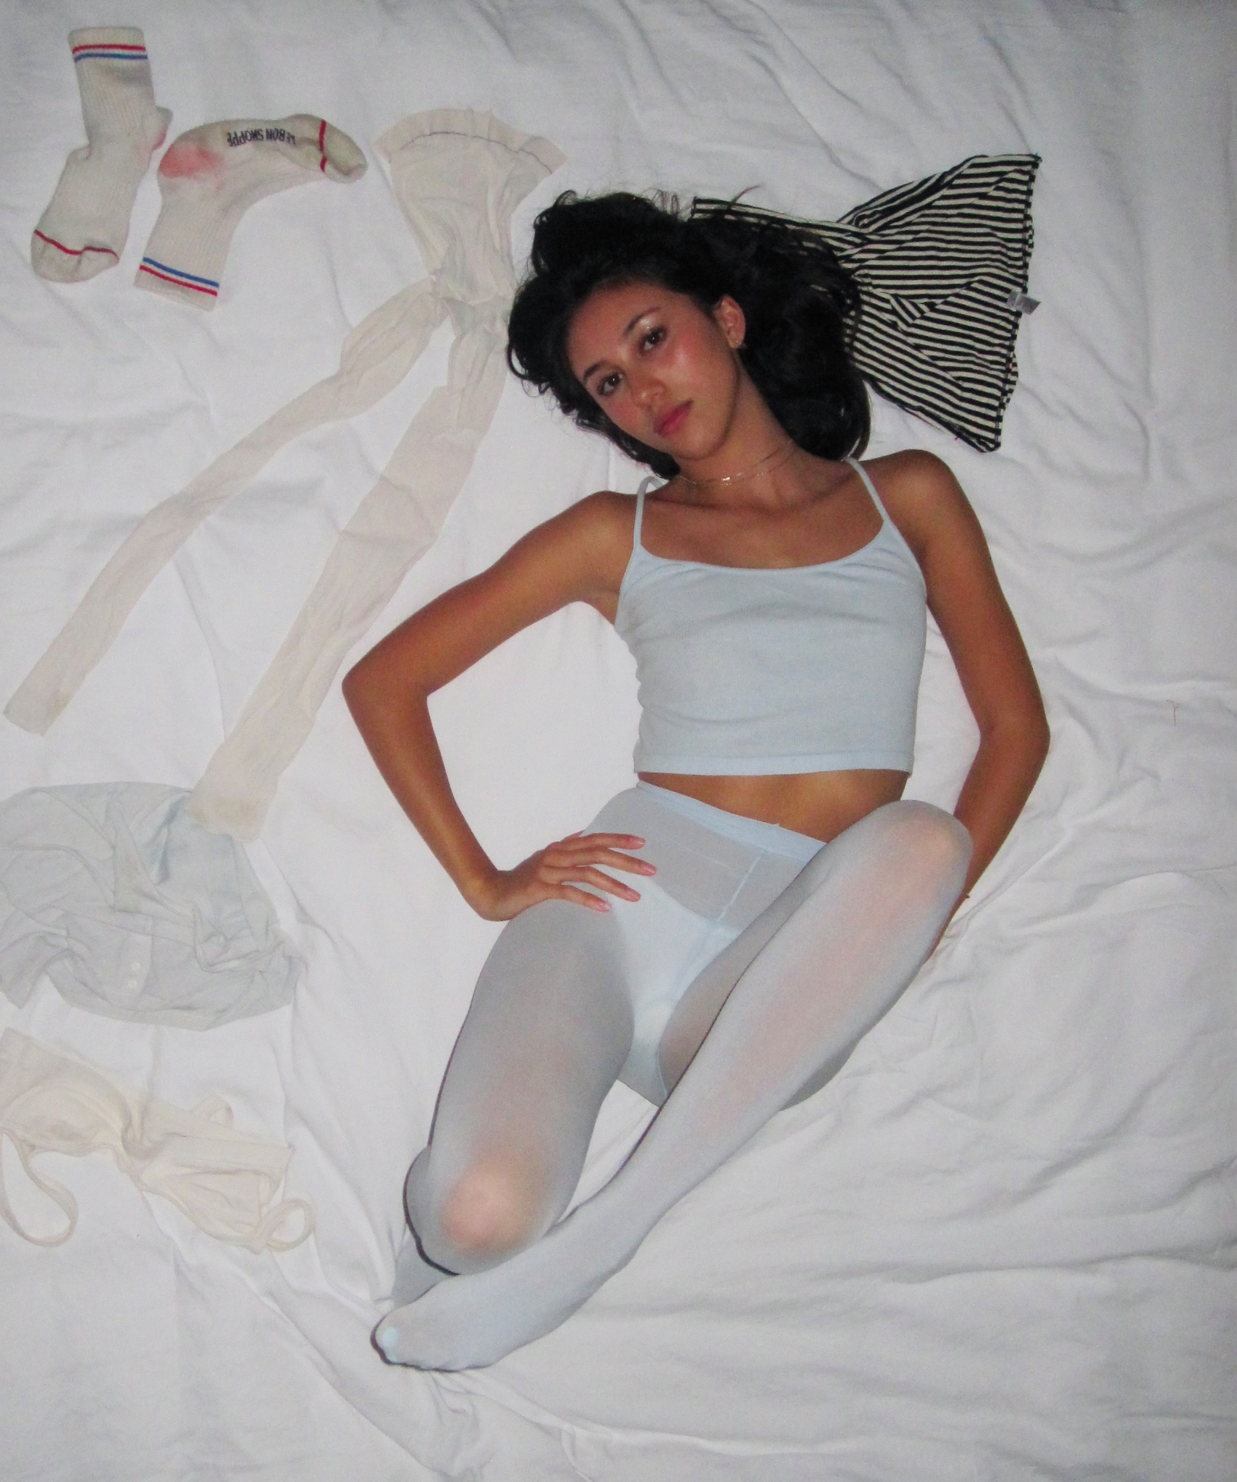

* + Description:
    - This image was shot on a digital camera. The model and staging was styled by me. I decided to shoot this from an aerial view to give off a more professional, editorial look, very reminiscent of the campaigns shot by Los Angeles Apparel. After hand selecting my favorite images, I edited it to give it a film look.

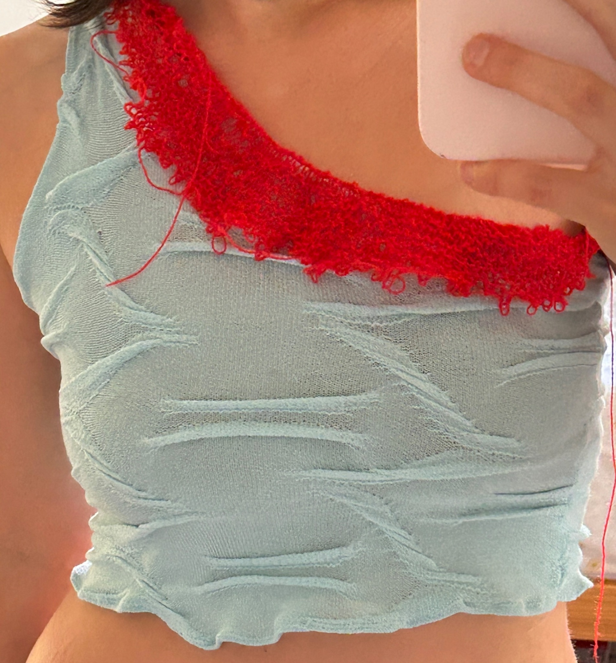

* + Description:
    - This top was reworked from an old golf polo that I had thrifted and I attached a red mohair neckline, knit by me!

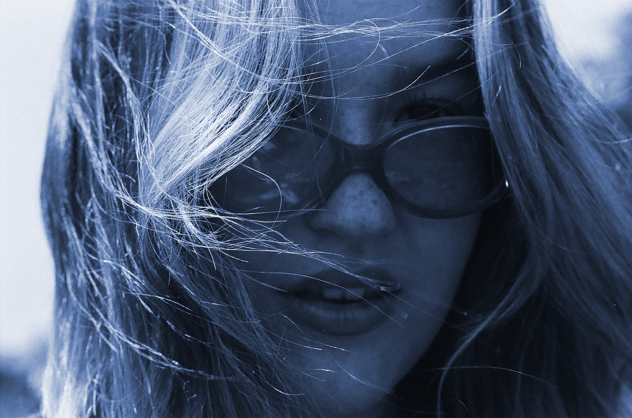

* + Description:
    - This project was shot on 35mm film. I manipulated the colors to create a blue overlay. The model was styled by me!

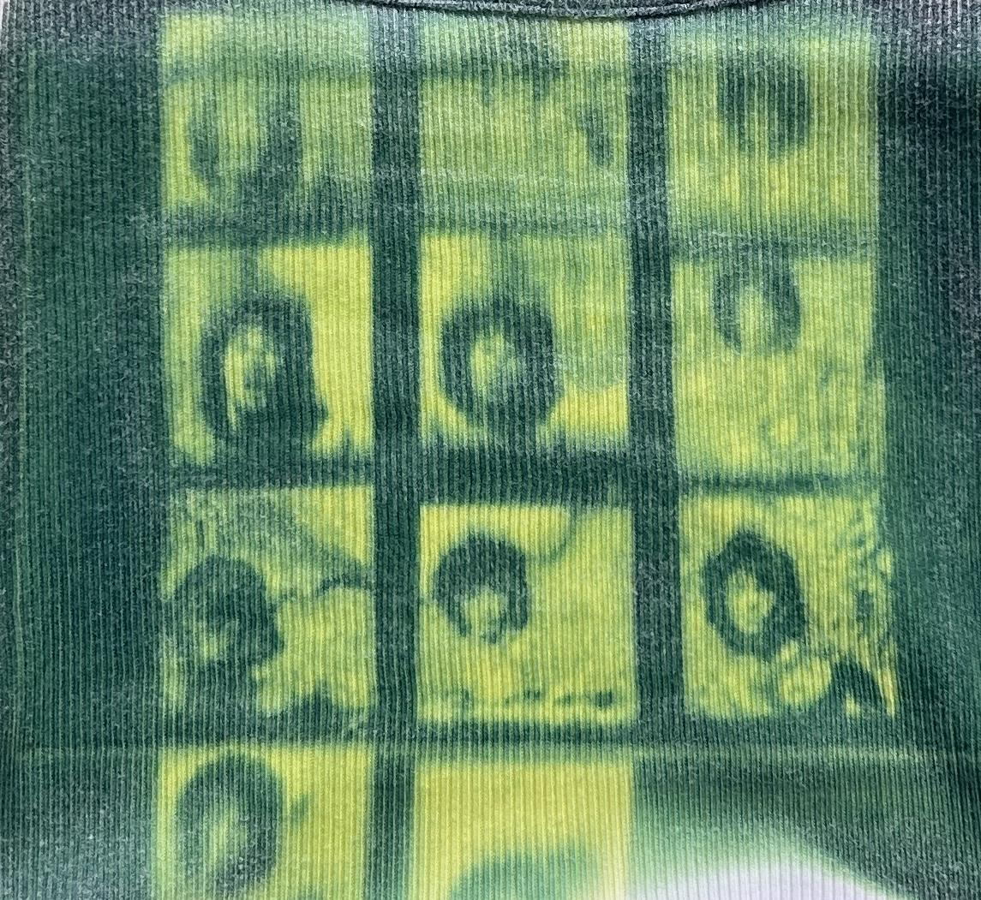

* + Description:
    - This was a cyanotyping project I worked on. I thrifted a white tank top, inverted hand selected images in photoshop to create negatives, printed it out on film paper and layed it over the sunprint formula. After the print sits in the sun for long enough, the outline of the image transfers and the color of the formula turns green. Before rinsing the formula off to turn it blue, a beautiful green/teal hue is made, which really caught my eye.